
INDIVIDUAL PROGRESS REPORT 1

Student Name: Muhammad Abdullah Athar
Student ID: 12214720
Contents
1. Overview 2
2. Evidence of Individual Contribution 2
3. Progress in Achieving Project Goals 4
4. Reflection and Professional Accountability 5
5. Planned Next Steps 5
6. Professional Conduct and Engagement 5

1. Overview
This report details my personal development in the project entitled Penetration Testing of Sensor Network in Compliance Reporting. The aim of this project is to model and simulate a simulated IoT sensor network and investigate its communication patterns and security properties.
The main task I had during this stage of the project was to configure the simulation environment and a working sensor network with the Contiki-NG Cooja simulator. This included setting up the simulation, deployment of nodes and making sure that the communication between nodes is set properly using the RPL routing protocol.
The work done so far is the successful deployment of the network and the preliminary observation of the communication behaviour of the network.

2. Evidence of Individual Contribution
The setup, configuration, and implementation of simulated sensor network were under my responsibility. I did the following tasks:
- Installed and setup Contiki-NG operating system, Cooja simulator.
- Developed a new Cooja simulation environment.
- Applied a sensor network with the RPL-UDP example.
- Placed various motes (one sink node and multiple client nodes).
- Enforced adequate communication among nodes via UDP over RPL.
- Listened to network traffic with the Radio Messages and Mote Output interfaces.
- Directly inspected packets in the simulator.
- Determined that there is no encryption of packet data.
These activities indicate a distinct correspondence to the duties that I have been entrusted with in the project proposal.
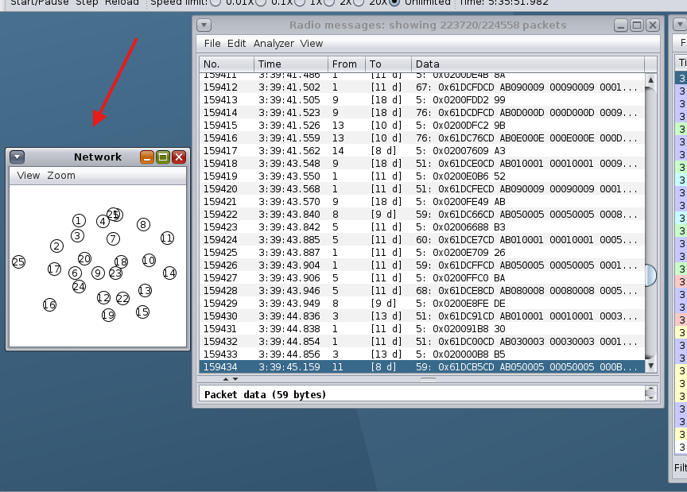
Figure 1 Initial Network Topology in Cooja Simulator
This figure shows how the sensor network initially appears in the Cooja simulator. There were several motes that were deployed, one sink node and several client nodes. The nodes are spread across the simulation area such that this forms a complete network topology. This configuration forms the basis of communication that employs the RPL routing protocol.
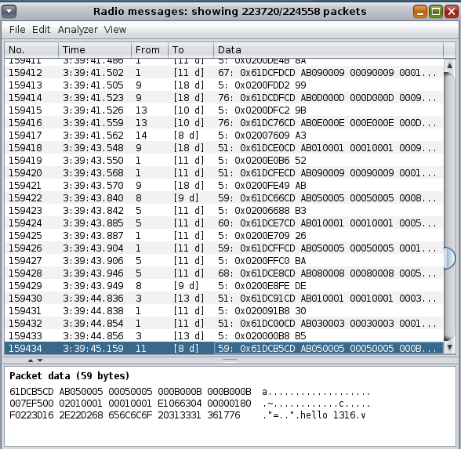
Figure 2 Packet Transmission Observed in Radio Messages
This figure shows the Radio Messages window, which shows the packet transmission in real time between the nodes. The entries are communication events, with the source node, the destination node and the packet data. The fact that the packet stream is constant is a pointer that the network is operating properly and that communication among nodes is effectively being achieved.
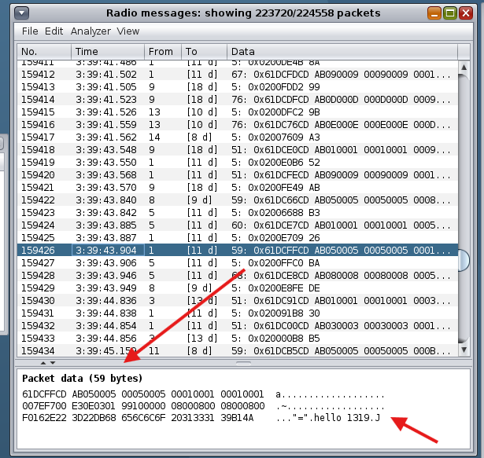
Figure 3 Packet Data Showing Unencrypted Communication
This number demonstrates the packet inspection in the simulator. The data sent can be seen by picking individual packets. The examination indicates that the data is in plain form without encryption or authentication. This implies that there are no security measures to the communication process and creates a possible vulnerability in the network.

3. Progress in Achieving Project Goals
Substantial progress has been made in achieving the initial objectives of the project. The sensor network has been installed and tested to work in normal operating conditions.
The simulation shows that nodes can effectively communicate with the help of the RPL routing protocol. Transmission of the packets which is observed using the Radio Messages interface proves that data is communicated constantly among the nodes.
Effective deployment of the network is a vital milestone, as it offers a testable environment to carry out additional tests and security audit. This development is a solid basis of the following stage of the project, the further analysis and penetration testing.

4. Reflection and Professional Accountability
Throughout the implementation process, I was faced with a number of difficulties caused by setting up the simulation setting and the format of the RPL-UDP example.
Initially, there were issues in running the simulation due to configuration errors and incorrect setup paths. These issues demanded several tries to solve, with one of them being reading documentation and trying various setups.
This process enabled me to understand more about the Cooja simulator and enhanced my problem solving abilities. Another practical experience that I gained was in debugging simulation environments and in analyzing network communication.
The experience has also helped me to grow technically and enhance my confidence in working with IoT simulation tools.

5. Planned Next Steps
The following stage of my activity will be to continue the analysis and help to complete the whole project. The proposed events will involve:
- Carrying out more in-depth packet communication analysis in the network.
- Examining the RPL routing behavior and message exchange further.
- Helping to detect possible vulnerabilities.
- Helping to prepare and organize the final report.
These measures will keep the project on track towards the achievement of the project goals.

6. Professional Conduct and Engagement
Throughout this phase, I have actively participated in project-related activities and completed all assigned tasks responsibly. I maintained consistent engagement in the project and contributed to discussions and problem-solving efforts.
Monitoring vulnerability
All work was conducted in a structured and ethical manner within a controlled simulation environment. My contributions clearly demonstrate alignment with the project requirements and expectations.

